Fatima Jinnah Women University
Department of Software Engineering


----------------------------------------------------------------------------------------------------------------------------------------

LAB #07

SUBJECT: CLOUD COMPUTING
SUBMITTED TO: SIR MUHAMMAD SHOAIB
SUBMITTED BY: Zainab Shahid
REGISTRATION NO: 2023-BSE-072
CLASS: BSSE V-B

Task 1 — Print & filter environment variables
Goal: Show environment variables and filter them using grep.
task1_printenv_all:
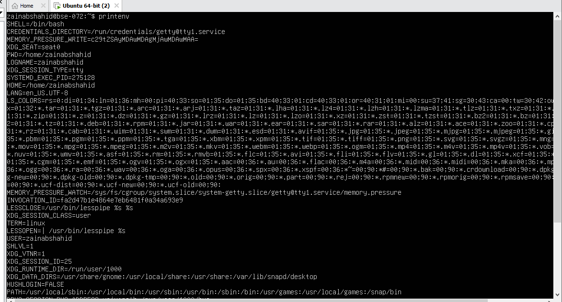

task1_grep_shell_home_user:
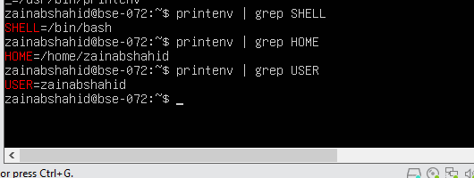
Task 2 — Export DB_* variables temporarily and observe scope
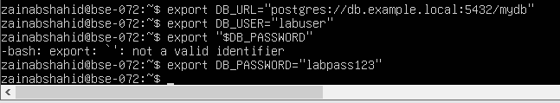
- Echo the three variables (run the three echo commands together) and capture one screenshot showing their outputs:
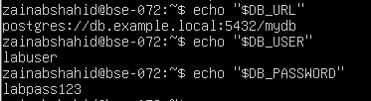
- Show all DB_ variables with a single grep command (capture that output):
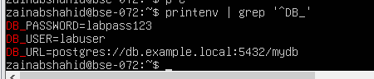
- Close the bash session (e.g., exit) and reopen a new terminal. Verify the variables are gone by running the echo(s) and the grep together; capture both checks in one screenshot:

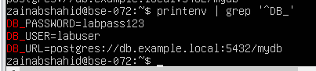
Task 3 — Make DB_* variables persistent in ~/.bashrc
Goal: Add DB_* variables to ~/.bashrc, reload, and verify persistence. Grouped captures: show the three export lines in ~/.bashrc together, and group the post-source checks into one screenshot.
- Open ~/.bashrc in an editor and append the three export lines. Capture the editor showing the three lines added (single screenshot):

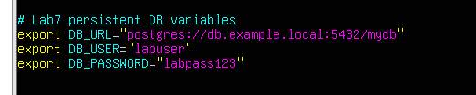
- Source ~/.bashrc and capture the source command in one screenshot together with the next verification commands (grouped): run source ~/.bashrc and then immediately run the three echoes and a single grep, capturing all of these in one screenshot:

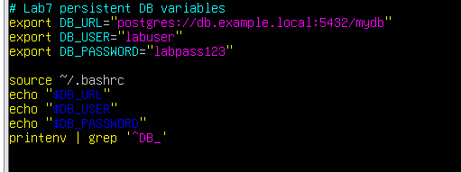

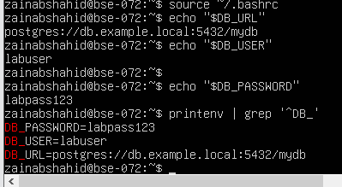
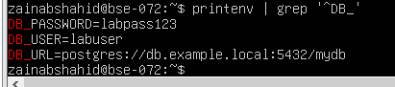
- Close and reopen terminal. Verify persistence by running one echo and the grep together — capture both in one screenshot:
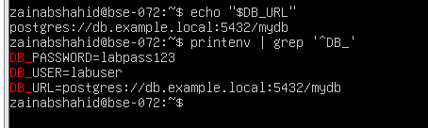
Task 4 — System-wide environment variable, welcome script, and PATH
Goal: Add Class variable to /etc/environment, view PATH, create a welcome script at ~/welcome, make it executable, and add PATH entry in ~/.bashrc so welcome can be executed without ./. Capture grouped screenshots as applicable.
Steps and required screenshots (grouping applies to "print with grep" type commands and grouped variable definitions — in this task there is a single system variable definition so a standard per-action capture is used):
- View /etc/environment:

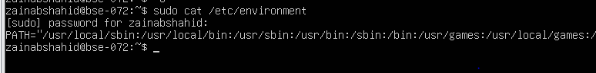
- Show current PATH:
- Edit /etc/environment and add Class:
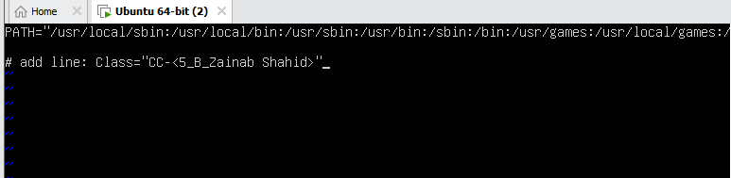
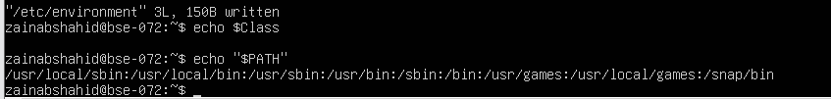

- Create welcome script at your home directory (~/welcome) and make it executable (capture the heredoc creation and chmod together in one screenshot if possible):

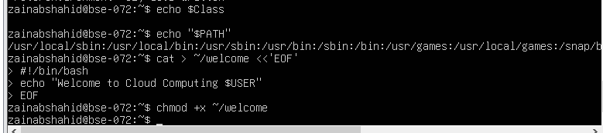
- Run the script from your home directory using ./welcome:
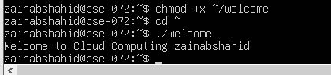
- Add your home directory to PATH in ~/.bashrc. NOTE: per your instruction we do not include an export PATH line here — only add the PATH modification line in the file. Capture the editor showing that PATH line in one screenshot:

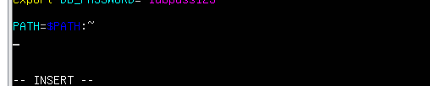
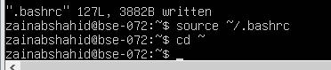
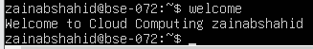
Task 5 — Block and allow SSH using ufw (firewall)
Goal: Use ufw to deny and allow SSH then verify SSH connectivity changes from host. Save screenshots after each logical command/step; group related print checks when appropriate.
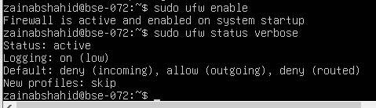
- Deny TCP port 22 and show status (run deny and status numbered together and capture in one screenshot). Use short form as requested:

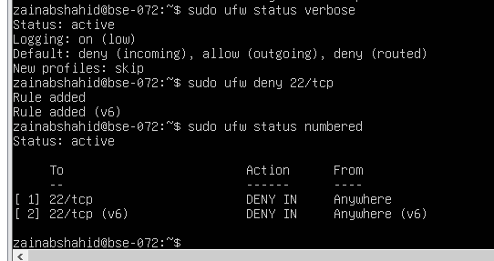
- From Windows host attempt to SSH (expected to fail) — capture the host-side SSH attempt in one screenshot:
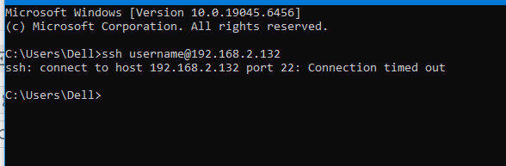
- Allow SSH back and reload, then show status (group allow, reload, status in one screenshot if run together). Use short form as requested:

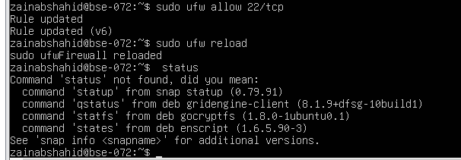
- From Windows host attempt SSH again (should succeed) — capture successful login in one screenshot:

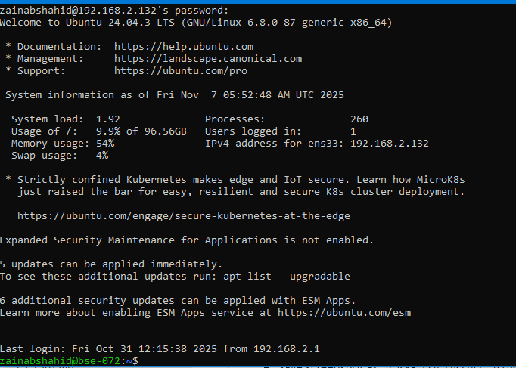
Task 6 — Configure SSH key-based login from Windows host
Goal: Copy your public key from the Windows host into the Ubuntu server's ~/.ssh/authorized_keys to allow passwordless SSH. Save grouped screenshots for the client-side actions and the server-side edits/checks.

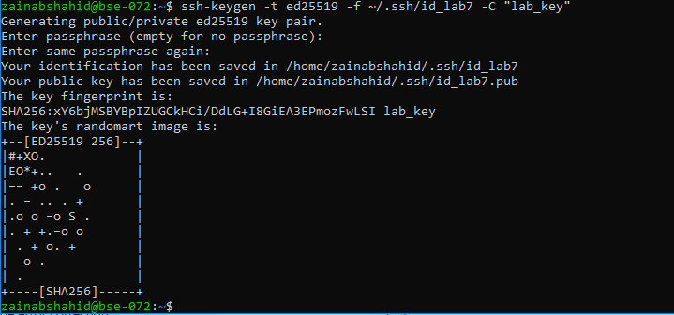
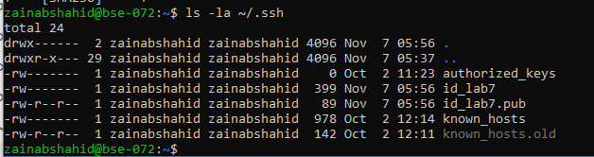
- Show the public key content (single screenshot):

- Clear the known_hosts file content and verify it is empty (single screenshot):
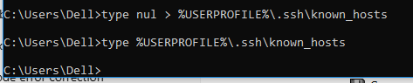
- Connect to the Ubuntu server using the standard SSH command (this will prompt to accept the server host key because known_hosts is empty). Capture the connection prompt/accept step in one screenshot:
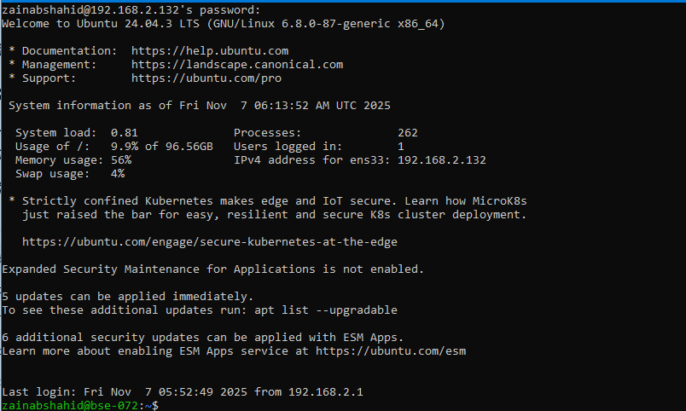
- After the successful connection, view the known_hosts file to show the server host key was added (single screenshot):
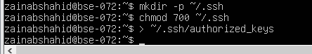
6.Append the public key, set file permissions, and show the resulting authorized_keys (capture commands and resulting file content in one screenshot):
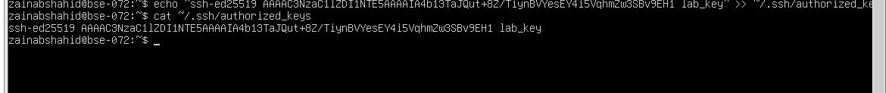
7.Append the public key, set file permissions, and show the resulting authorized_keys (capture commands and resulting file content in one screenshot)
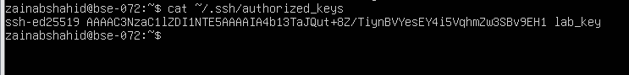
- From Windows host test passwordless login (capture successful login in one screenshot):
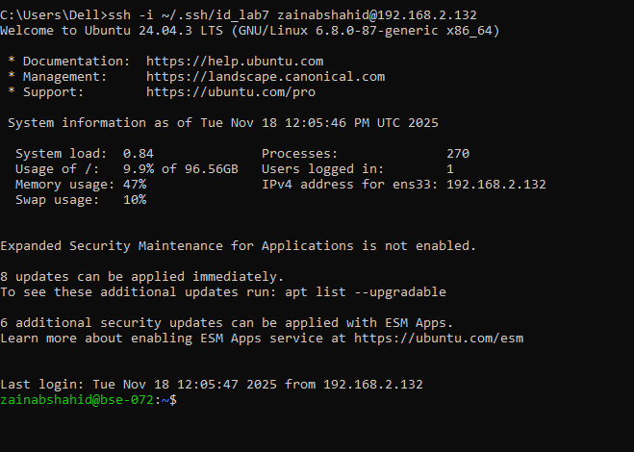
Exam Evaluation Questions
Q1: Quick Environment Audit
- Objective: Demonstrate you can inspect the current environment and extract a few key variables.
- Actions & evidence:
  - Run a single command to display environment variables and capture its output.
    - Save screenshot: EE_q1_env_all.png
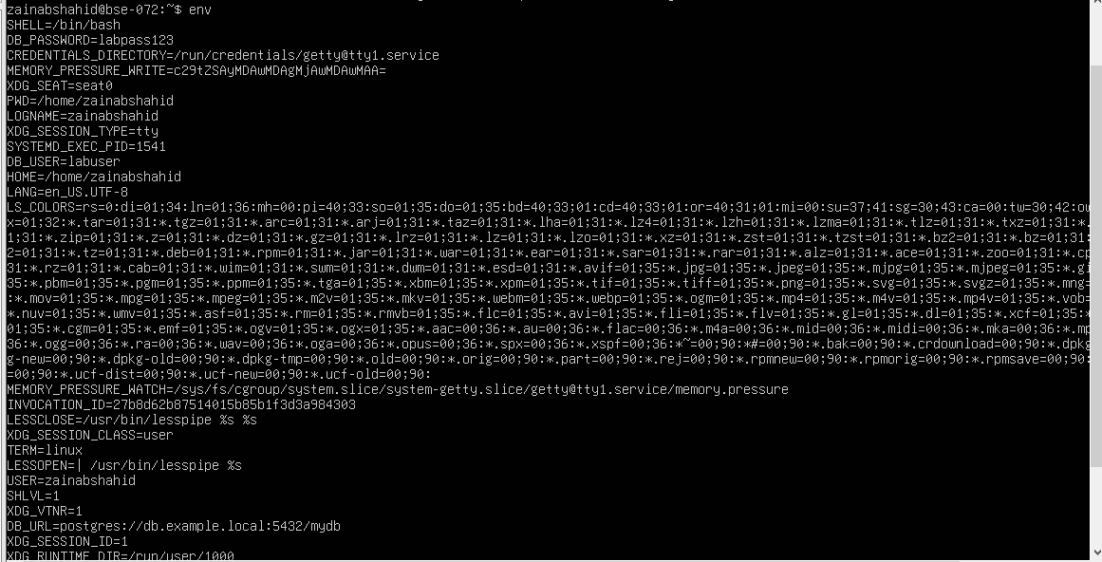

  - In the same terminal session, run three filters (one per line) to show values for PATH, LANG, and PWD, then capture a single screenshot showing the three outputs together.
    - Save screenshot: EE_q1_env_filters.png
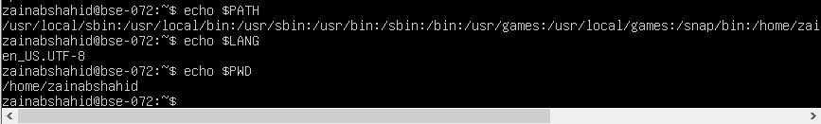
Q2: Short-lived Student Info
- Objective: Show how temporary environment variables behave (session-scoped).
- Actions & evidence:
  - In one terminal, set three variables (STUDENT_NAME, STUDENT_ROLL_NUMBER, STUDENT_SEMESTER) using export — execute all three consecutively and capture them in one screenshot (show the commands executed).
    - Save screenshot: EE_q2_exports.png
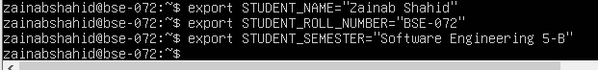
  - Still in the same session, print the three values with echo (grouped) and capture the outputs in one screenshot.
    - Save screenshot: EE_q2_echoes.png
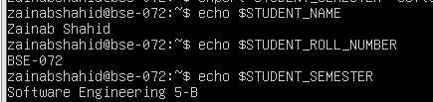
  - Use a single printenv|grep command to list any STUDENT_ variables and capture the result.
    - Save screenshot: EE_q2_printenv_grep.png
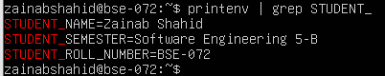
  - Exit that shell, open a fresh terminal, and show that the STUDENT_ variables are not set (use echo and printenv|grep together) — capture in one screenshot.
    - Save screenshot: EE_q2_after_restart.png
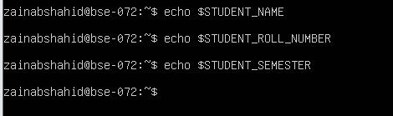
Q3: Make It Sticky (Persistence Check for Student Info)
- Objective: Demonstrate persistence of environment variables across sessions via shell configuration.
- Actions & evidence:
  - Edit ~/.bashrc and append the three STUDENT_* exports. Capture a screenshot of the editor showing the new lines.
    - Save screenshot: EE_q3_bashrc_editor.png
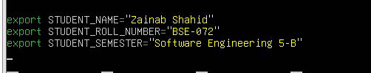
  - Reload your shell config with a single command and then verify the three variables and show printenv | grep '^STUDENT_' — capture these verification outputs together in one screenshot.
    - Save screenshot: EE_q3_after_source.png
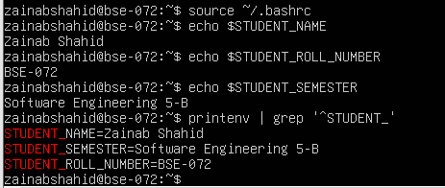
  - Close and re-open a terminal and demonstrate the STUDENT_NAME variable is available (echo and printenv grep together) — capture in one screenshot.
    - Save screenshot: EE_q3_after_restart.png
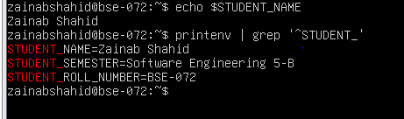
Q4: Firewall Rules: Block and Restore Ping (ICMP)
- Objective: Demonstrate you can block ping (ICMP echo) traffic using ufw and then re-allow it; show effect from a client.
- Actions & evidence:
  - Enable ufw and capture the enable command and status together in one screenshot.
    - Save screenshot: EE_q5_ufw_enable_status.png
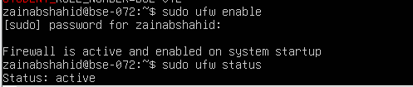
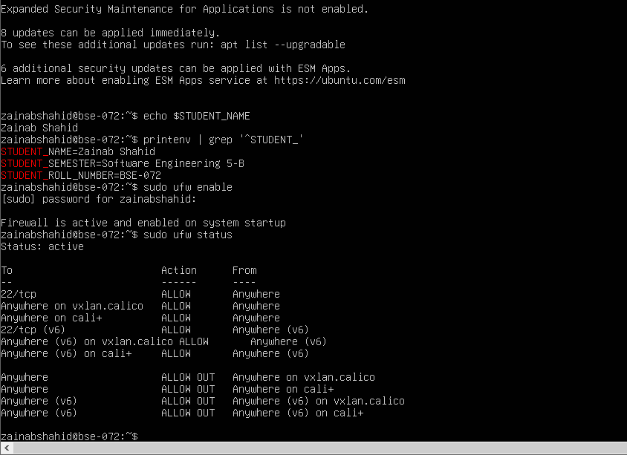
  - Add a rule to block ping (ICMP echo) and show ufw status numbered in the same screenshot.
    - Suggested command example:
    - sudo ufw deny proto icmp from any to any
sudo ufw status numbered
    - Save screenshot: EE_q5_ufw_deny_ping_status.png

  - From your Windows host (or another client), attempt to ping the server while the rule is active and capture the blocked/failing ping in one screenshot.
    - Save screenshot: EE_q5_ping_blocked.png
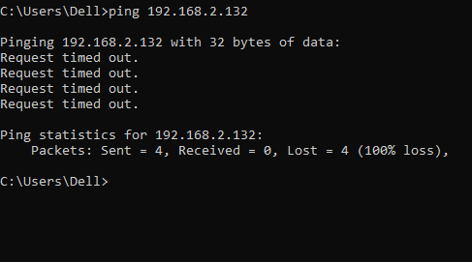
  - Re-allow ping (ICMP) (or remove the deny rule) and capture the allow/reload/status sequence in one screenshot.
    - Suggested command example:
    - sudo ufw allow proto icmp from any to any
    - sudo ufw reload
sudo ufw status
    - Save screenshot: EE_q5_ufw_allow_ping_status.png
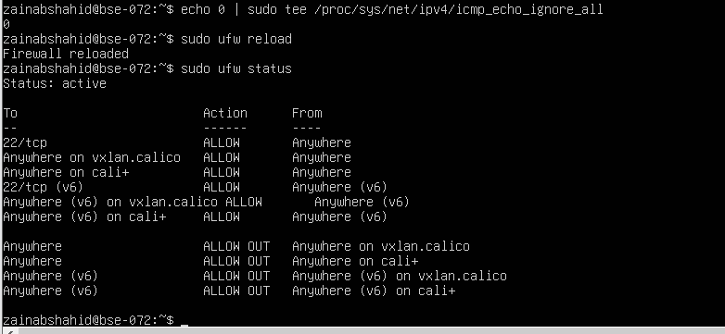
  - From the client, ping the server again and capture successful replies in one screenshot.
    - Save screenshot: EE_q5_ping_success.png

